**Angular 6 Notes (**<https://www.youtube.com/watch?v=Cuyf1k4bIzc&list=PL6n9fhu94yhWNJaDgh0mfae_9xoQ4E_Zj&index=1>)

npm run ng-high-memory

ng serve --port 4300

npm run

**Angular 6 Cover Topics**

* Part-3,4 Angular 6 Routing Tutorial
* Part 5: There are two way to createforms in angular(Template Driver,ReActive form{ ReActive form Also called model driven form})
* Part 5: Description about Form Group and Controller.
* Part 6: Angular nested form group
* Part 7: Angular setValue And Patch value
* >ReActive form controller
* >Angular nested form group
* >SetValue And PatchValue value method
* > Part 8: Angular Form Builder (Angular form builder example)
* >Part 9:Implementing Validation in form builder form
* Part 10: Angular Form Control value changes
* Part 11>Loop through all form controls in form group in :reactive form (Important)
* Part 12,13>Move validation messages to the component class in reactive form
* Part 14 > Dynamic add or remove validators at runtime in reactive form
* Part 15> Creating and using custom validator in an angular Reactive form
* Part 16> Using custom validator with parameter
* Part 17>Reusable custom validator (Important)
* Part 18>Angular Cross Field validator
* Part 19,20>FormArray
* Part 21> Angular dynamic form tutorails
* Part 22> Generate unique id value for dynamic created for controls (important Angular 2 tutorail 11 )
* Part 23> Dynamic form validation
* Part 24 > Form Array Validation
* Part 25 >Remove dynamically created form controls in angular
* Part 26 >
  + How to create fake json- server
  + RxJS operators in angular services
* Part 27> Reactive form edit example
* Pat 28 ? Angular populate form array
* Part 29: Angular Put requests
* Part 30: Angular Post requests
* Part 31: Angular Module Explained
* Part 32:Creating routing module in Angular : Creating separate routing module for a feature modules
* Part 33:
* Part 34:Creating Shared Module (ng g m shared/Shared –flat –m employee/employee)
* Part 35: Grouping Routes and creating Component less Routes in Angular
* Part 36:
* Part 37:
* Part 38:

**Update in Angular 6**

1. We can easily upgrade to our project to new version

ng update (Normal package manager command)

1. Rsjx update:
   1. Rsjx 6 introduce in new package.
   2. Operator concept

Update using cmd: npm install –save rsjx@6

For update whole project

npm install –save rsjx-compact

1. Multiple same pakage import in single import

Before:

Import{Obesrvable} from rsjx/Observable

Import{Subject} from rsjx/Subject

In new

Import{Obesrvable,Subject} from rsjx

1. <template> deprecated now Angular 6 <ng-template>

<ng-template [ngif]=”IsAdmin”>

1. Service level changes

In earlier version if we want to provide a service then we need to add in appModule in provider[] but in 6 version you should not add in the providers

So now we import in which module where we want to use.

1. Angular 6 introduce element that allows you to complile angular component to native web components which you can use in angular application

element package: @angular/elemnts

1. Rename some operators:

catch() => catchError()

do() => tap()

finally() => finalize()

switch() => switchAll()

Additionally, some Observable-creation methods were renamed/ refactored:

throw() => throwError()

fromPromise() => from()

1. We can add multiple vadidors for method array of form builder by comma seperator ex[ Validaor.required,Validator.minlength….].
2. Major change:CLI update and Add new project config file.

Instead of .angular-cli.json using angular.json

Update using

Ng update @angular/cli –from=I –migrate-only

10.

**How to create fake json- server**

npm install –g json-server

**launch new json server for data :**

json-server --watch db.json(json file name)

# The RxJS library (<https://angular.io/guide/rx-library>)

Reactive programming is an asynchronous programming paradigm concerned with data streams and the propagation of change ([Wikipedia](https://en.wikipedia.org/wiki/Reactive_programming)). RxJS (**Reactive Extensions for JavaScript**) is a library for reactive programming using observables that makes it easier to compose asynchronous or callback-based code. See ([RxJS Docs](https://rxjs.dev/guide/overview)).

RxJS provides an implementation of the Observable type, which is needed until the type becomes part of the language and until browsers support it. The library also provides utility functions for creating and working with observables. These utility functions can be used for:

* Converting existing code for async operations into observables
* Iterating through the values in a stream
* Mapping values to different types
* Filtering streams
* Composing multiple streams

**Send emails using Node.js, Nodemailer and Angular**  https://www.youtube.com/watch?v=p4bnK0qy89w&t=167s

node -v

npm -v

**For enviroment setup**

**Install Angular CLI and Create Angular 6 Web Application**

To install or upgrade the latest Angular 6 CLI, type this command in the terminal or Node command line.

* Sudo npm install -g @angular/cli (if install first time)
* Sudo npm install -g @angular/cli@latest (For update )

**Note:** If you use windows, it might be not necessary to add `sudo`.

**Next, create a new Angular 6 Web Application using this Angular CLI command.**

ng new angular6-start

**Next, go to the newly created Angular 6 project folder.**

cd ./angular6-start

**Now, you run the new Angular 6 web application using your own host and port.**

ng serve --host 0.0.0.0 --port 3000

or ng serve --open

or ng s –o

**Configure BootStrap for angular 6 application**

Npm install bootstarp@3 jquery –save

**Create Component**

ng g c employee/create-employee --spec=false --flat=true

ng g c employee/list-employee --spec=false --flat=true

ng – angular cli command, g for generate, c for component , employee is a folder,

--spec=false --flat=true we don’t want to generate spec file or unit test file

After this command CreateEmployeeComponent and listEmployeeComponent added in app.module.ts file and declare in @ngmodule declaration

ng g c tpr/create-update-tpr --module app

**Create routing module**

Ng g m app-module --flat=true –module app

m for module

--flat=true --module=app **(If we to seprate routing module)**

**Note : we import created routes in app-routing.module.ts file**

**Like**

**import {RouterModule,Routes} from “@angular/router”**

**Const appRoutes:Routes = [**

**{path:’list’,component:ListEmployeeomponent}**

**{path:’create’,component:CreatetEmployeeomponent}**

**{path:’’,redirectTo=’/list’,pathMatch=’full’ }**

**];**

**Q. Why a seperate routing module?**

* maintainibility
* Seperation of concern

**Create forms in angular**

There are two way to create forms in angular

* Template Driver
* ReActive form{also called model driven form}

**Classes for creating a form control tree**

* Form Group
* Form Control

**1.Form Group (Important Descripion in part 6)**

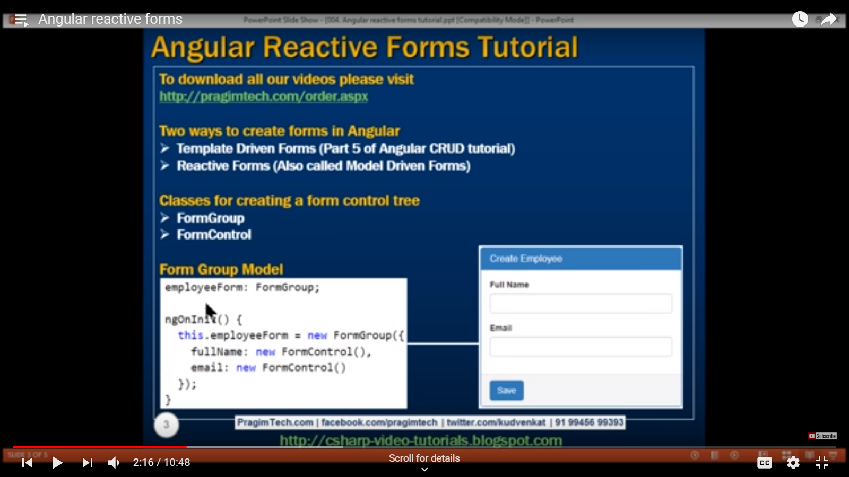

**Start Form Group:**

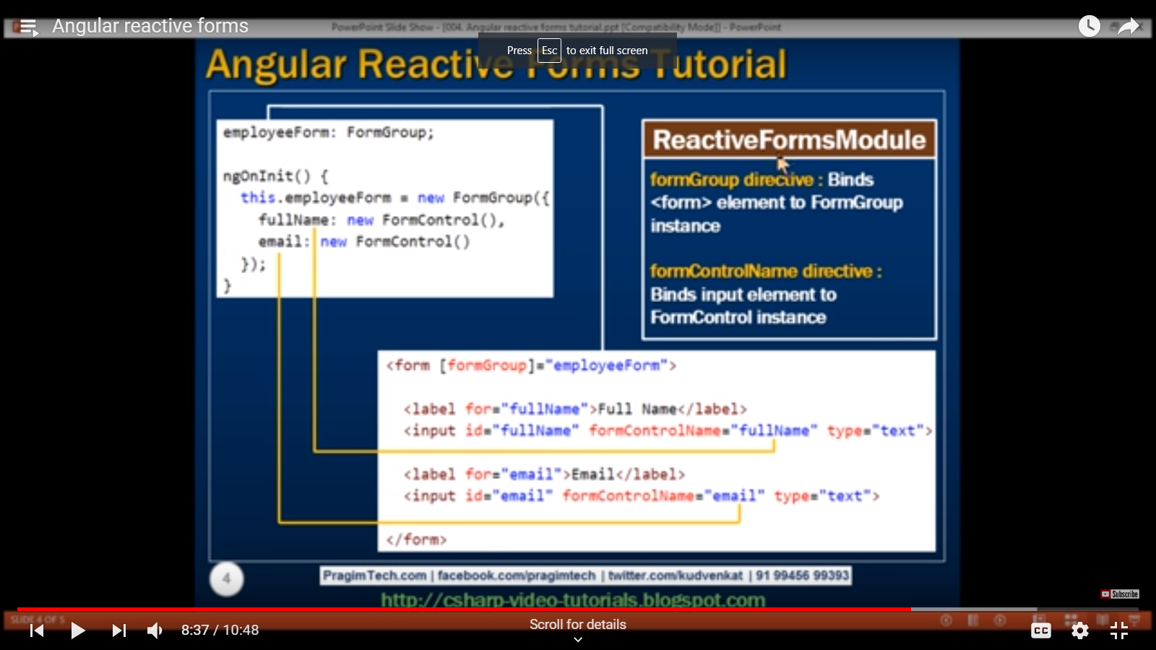

**Step to create Form Group:**

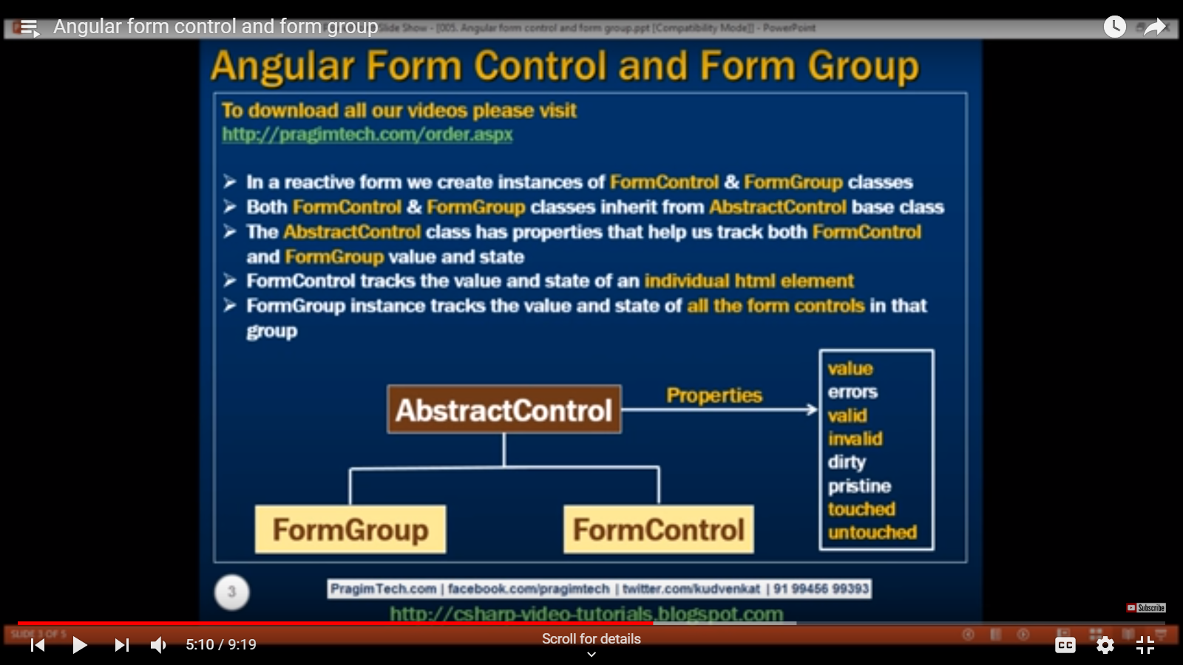

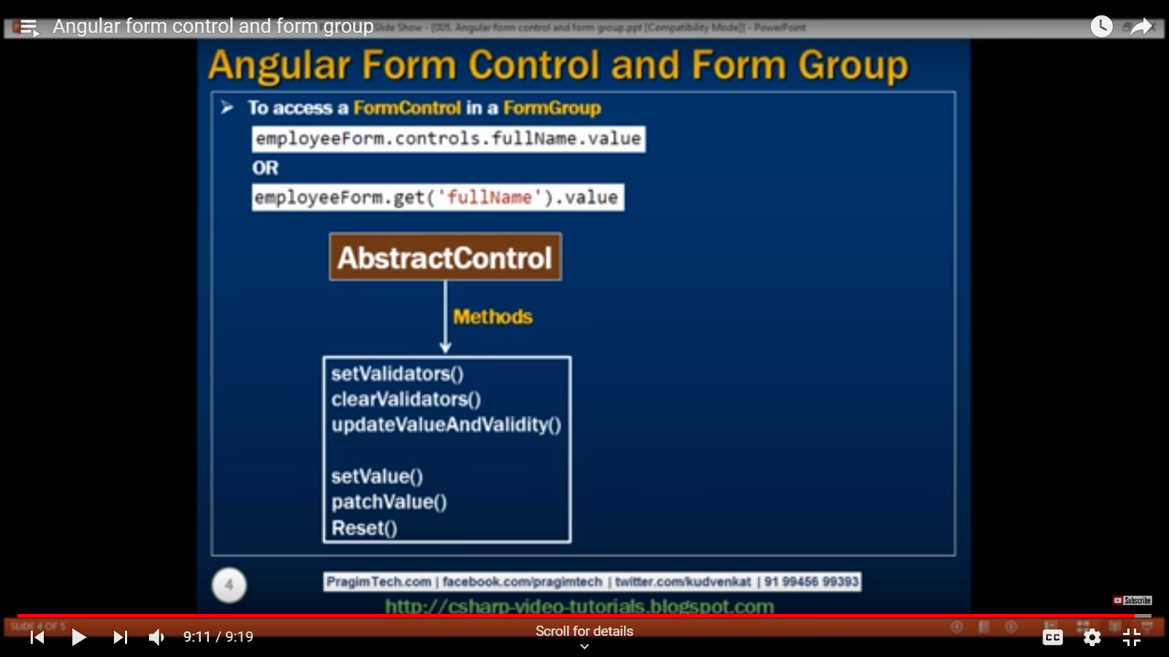

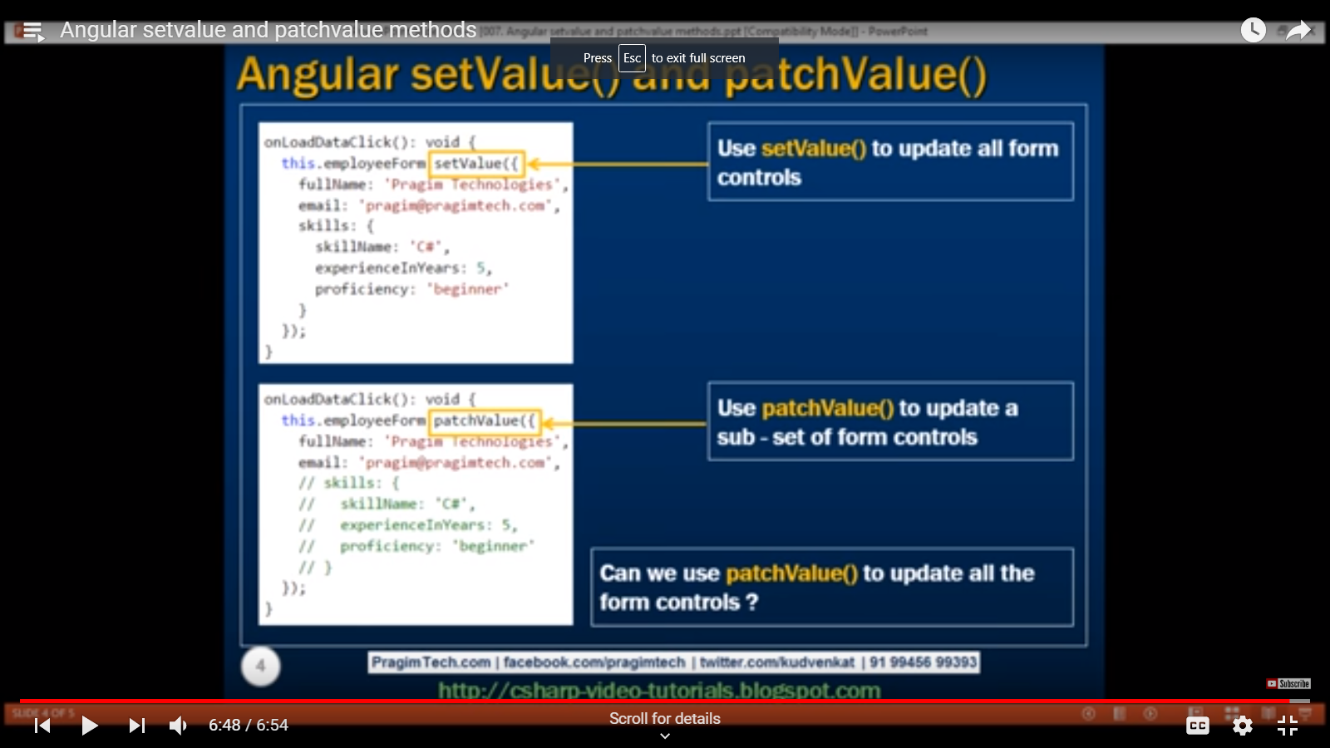

**Part 8:**

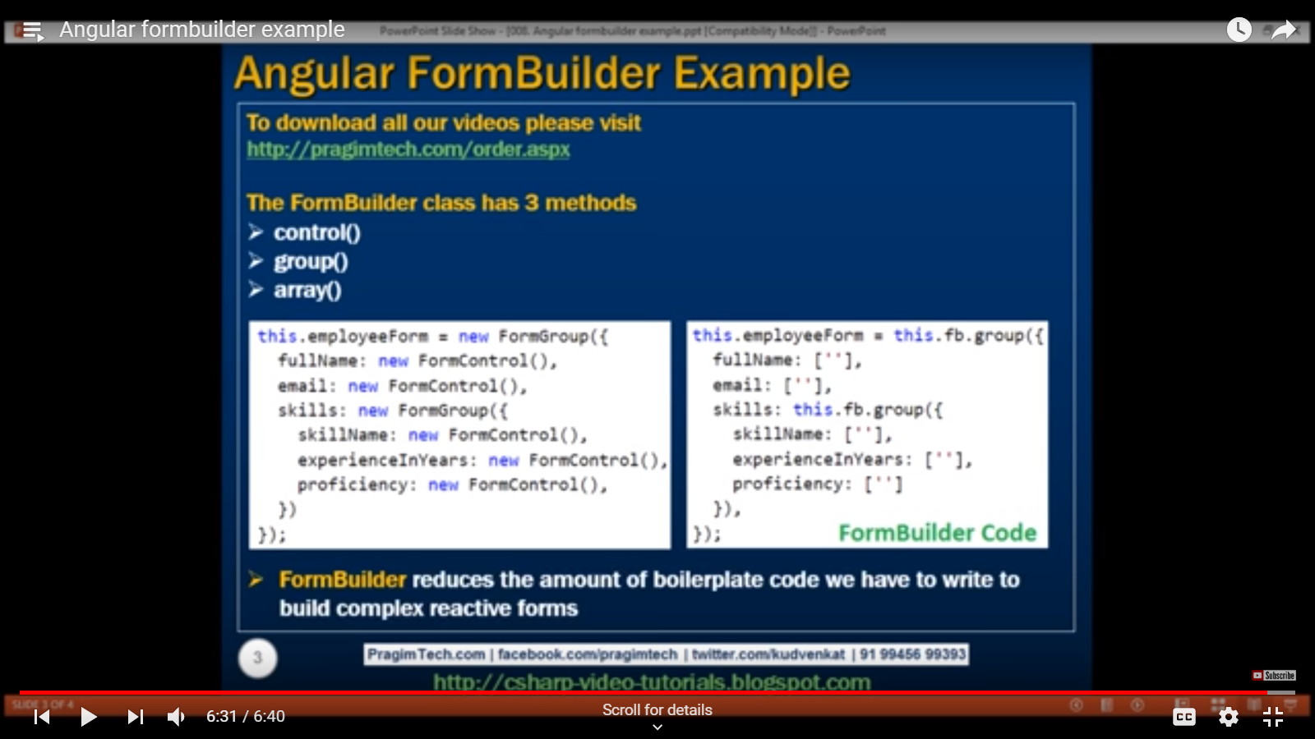

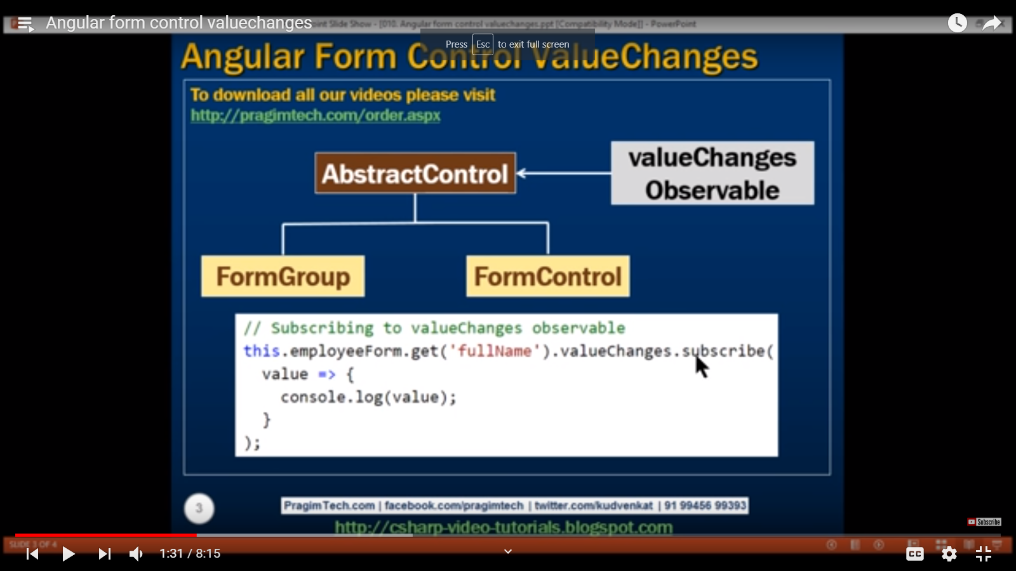

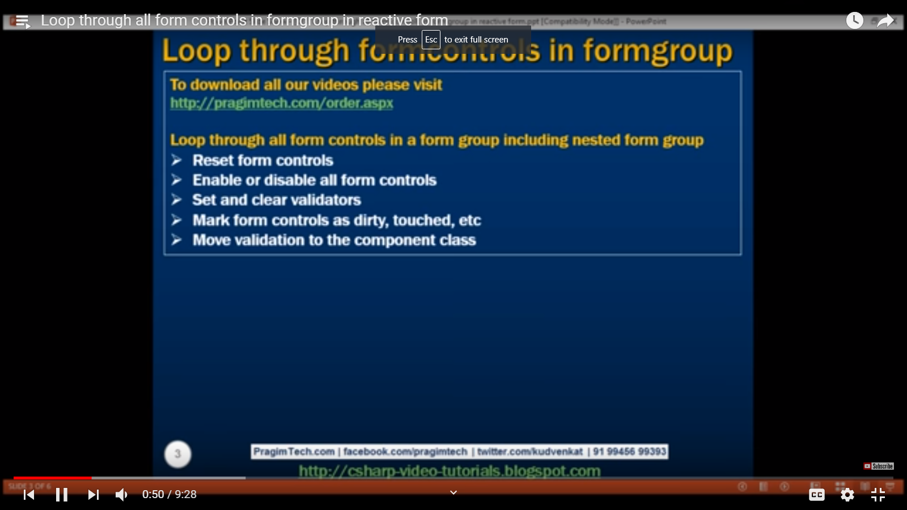

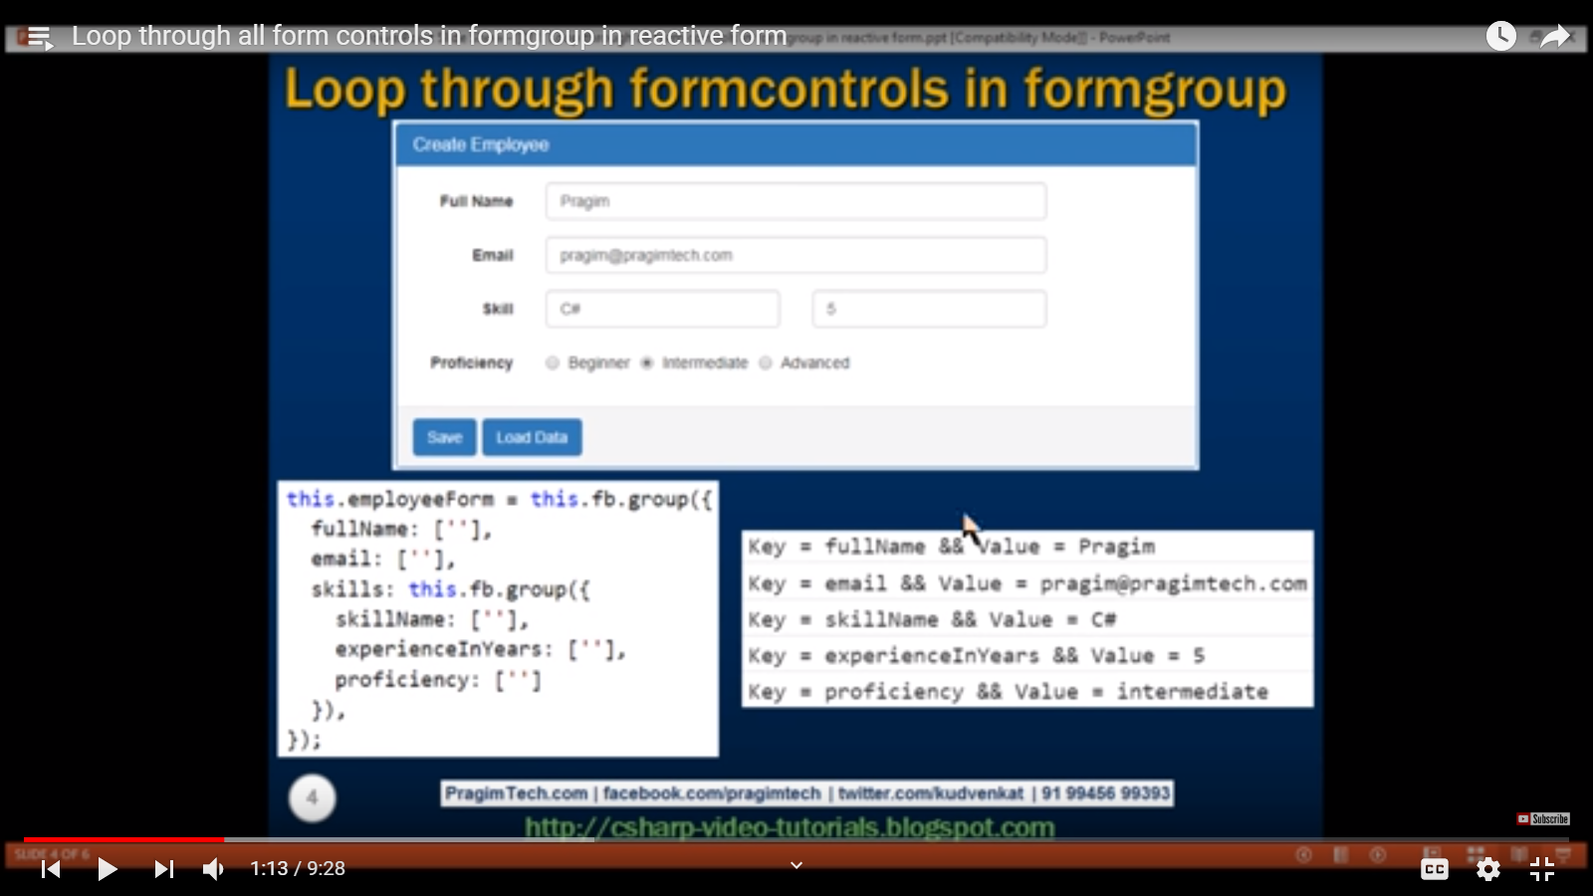

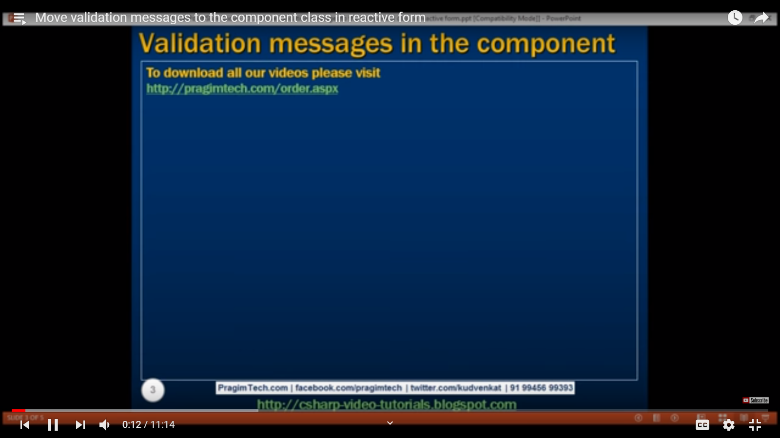

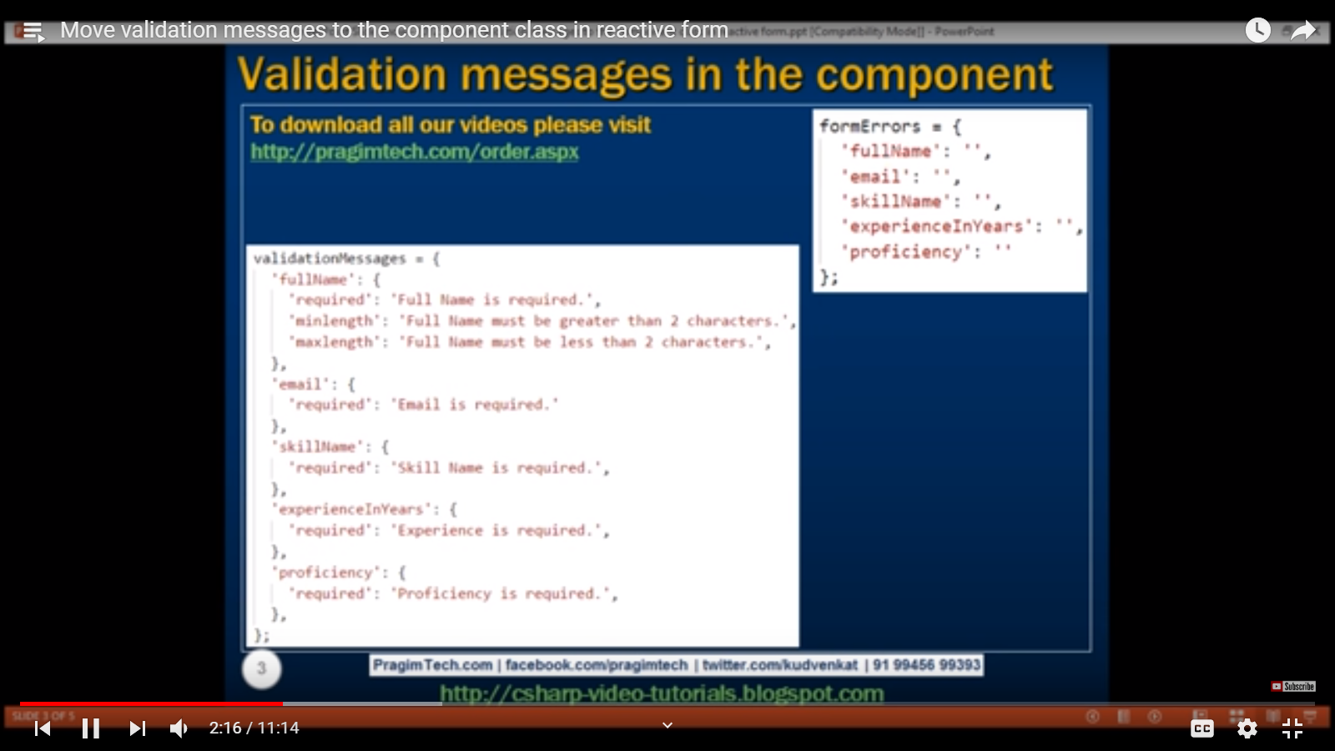

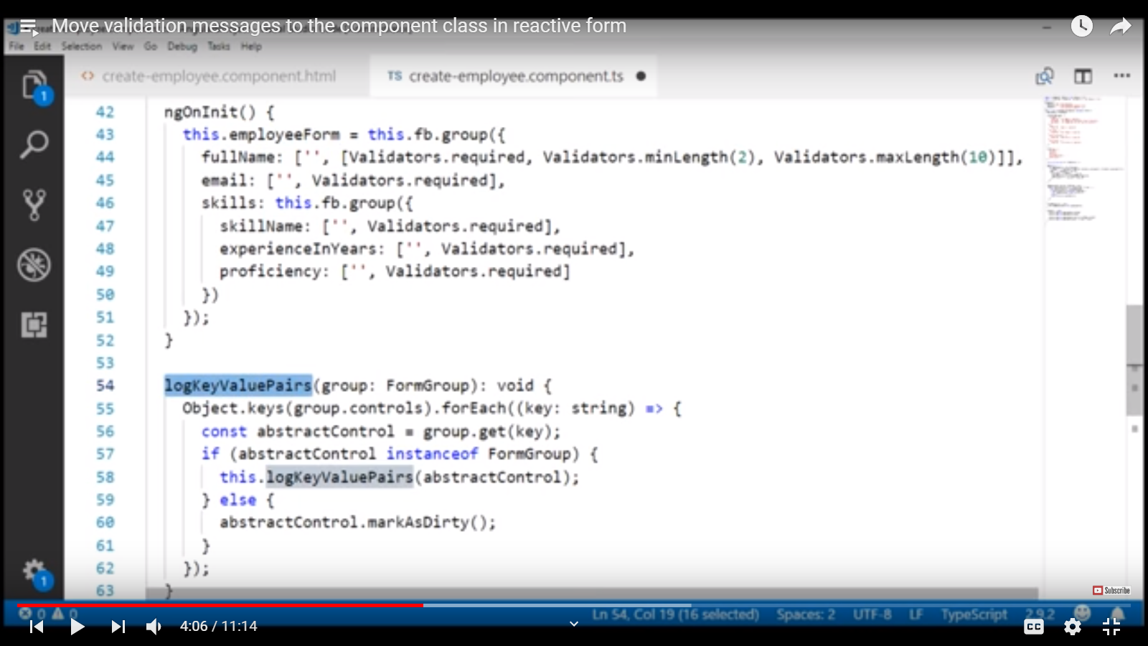

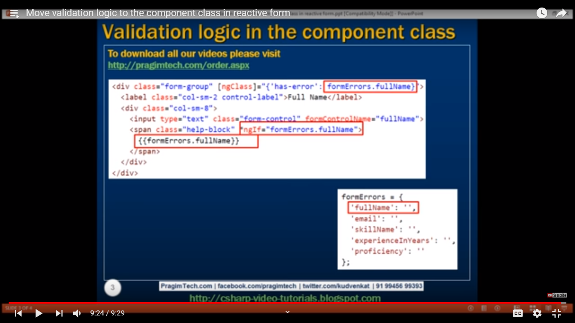

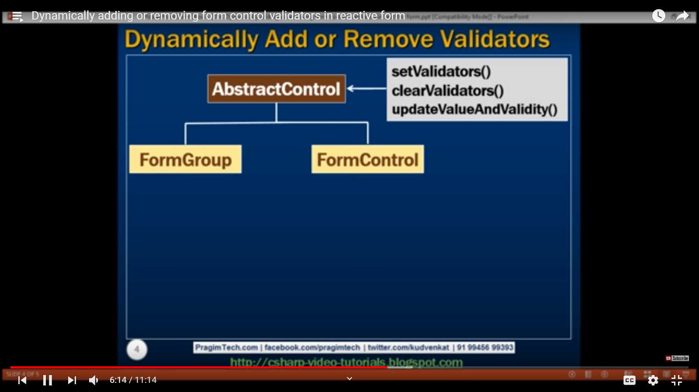

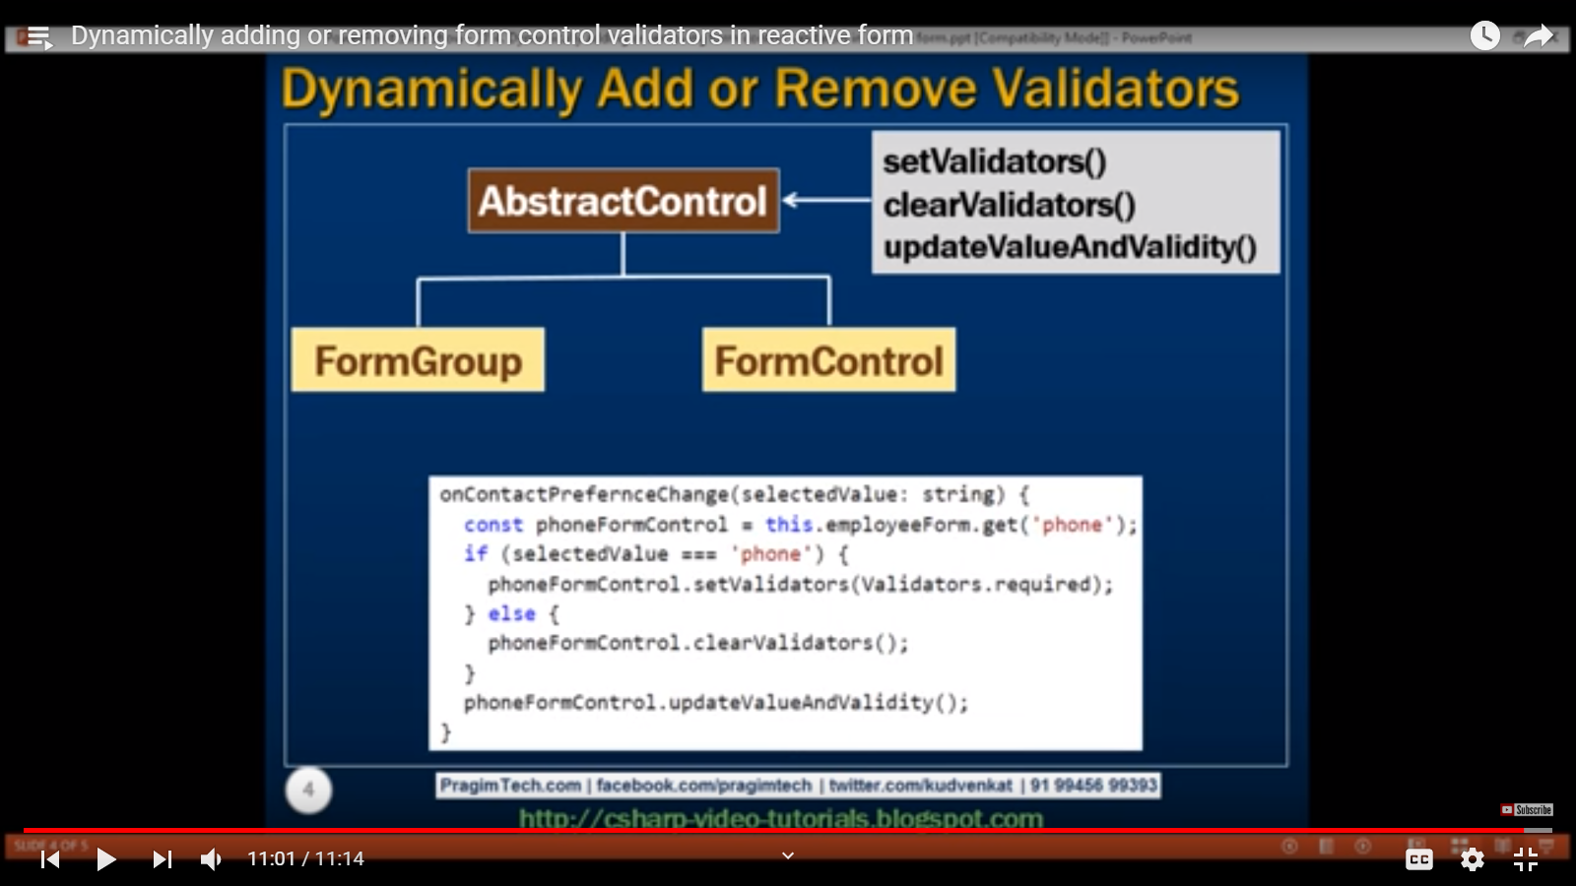

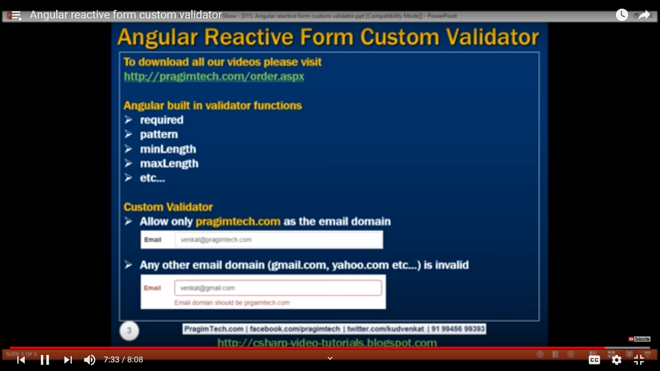

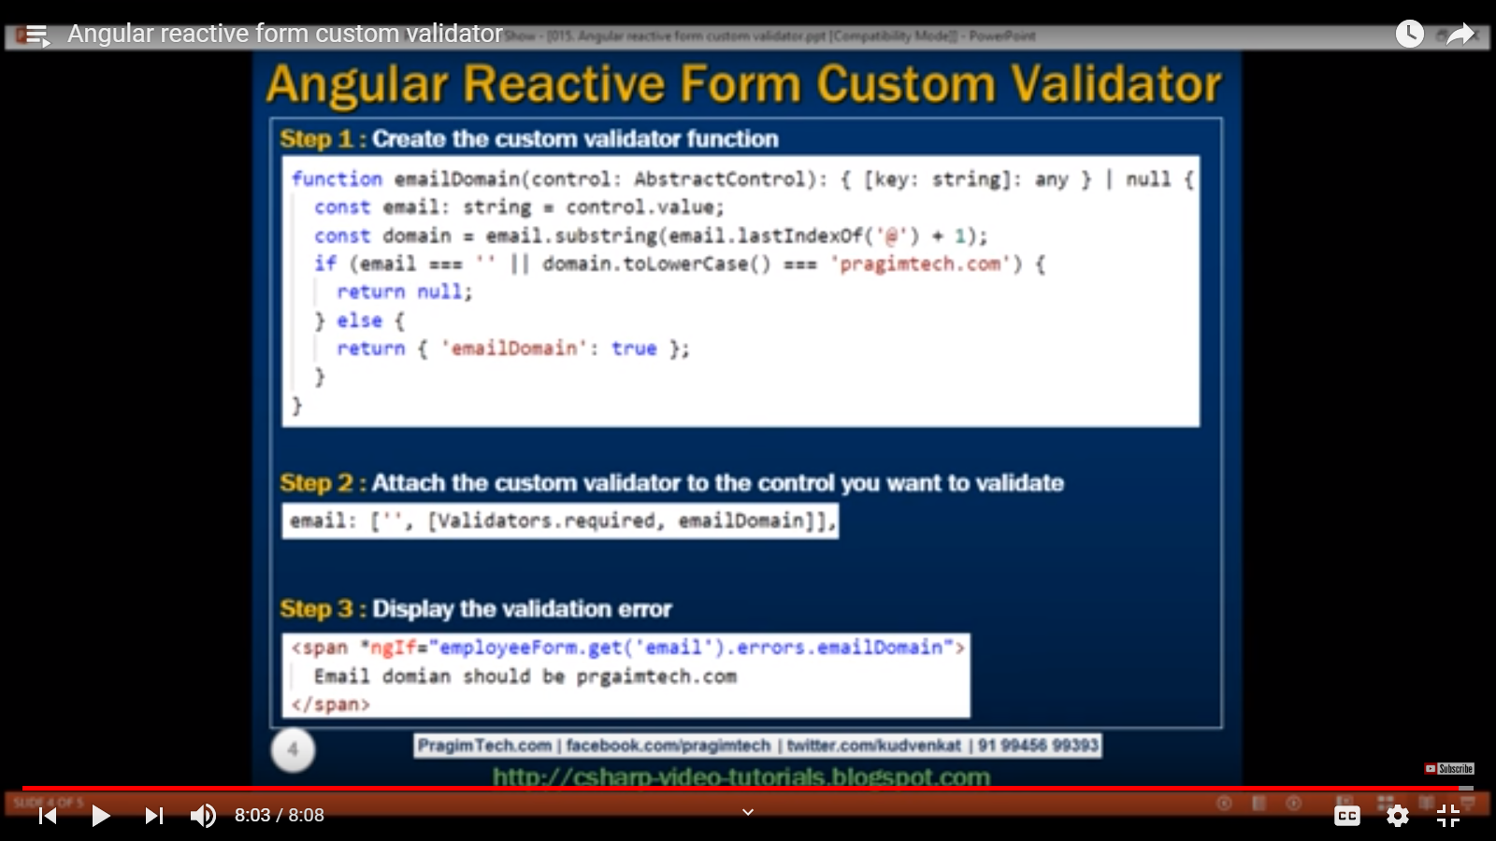

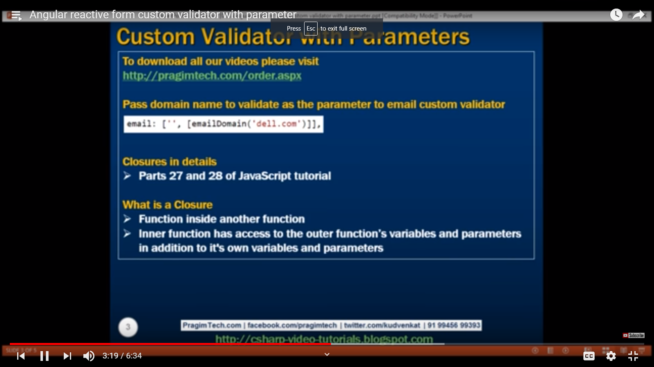

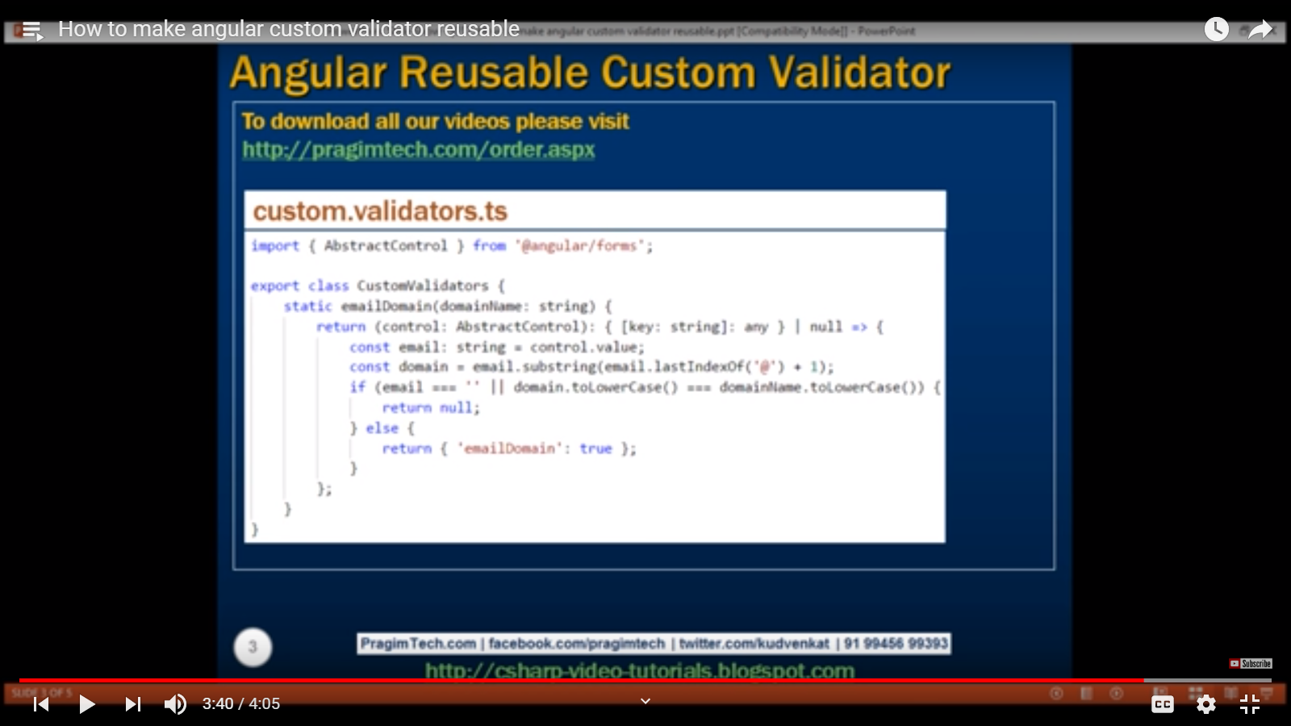

**Part 19,20>FormArray**

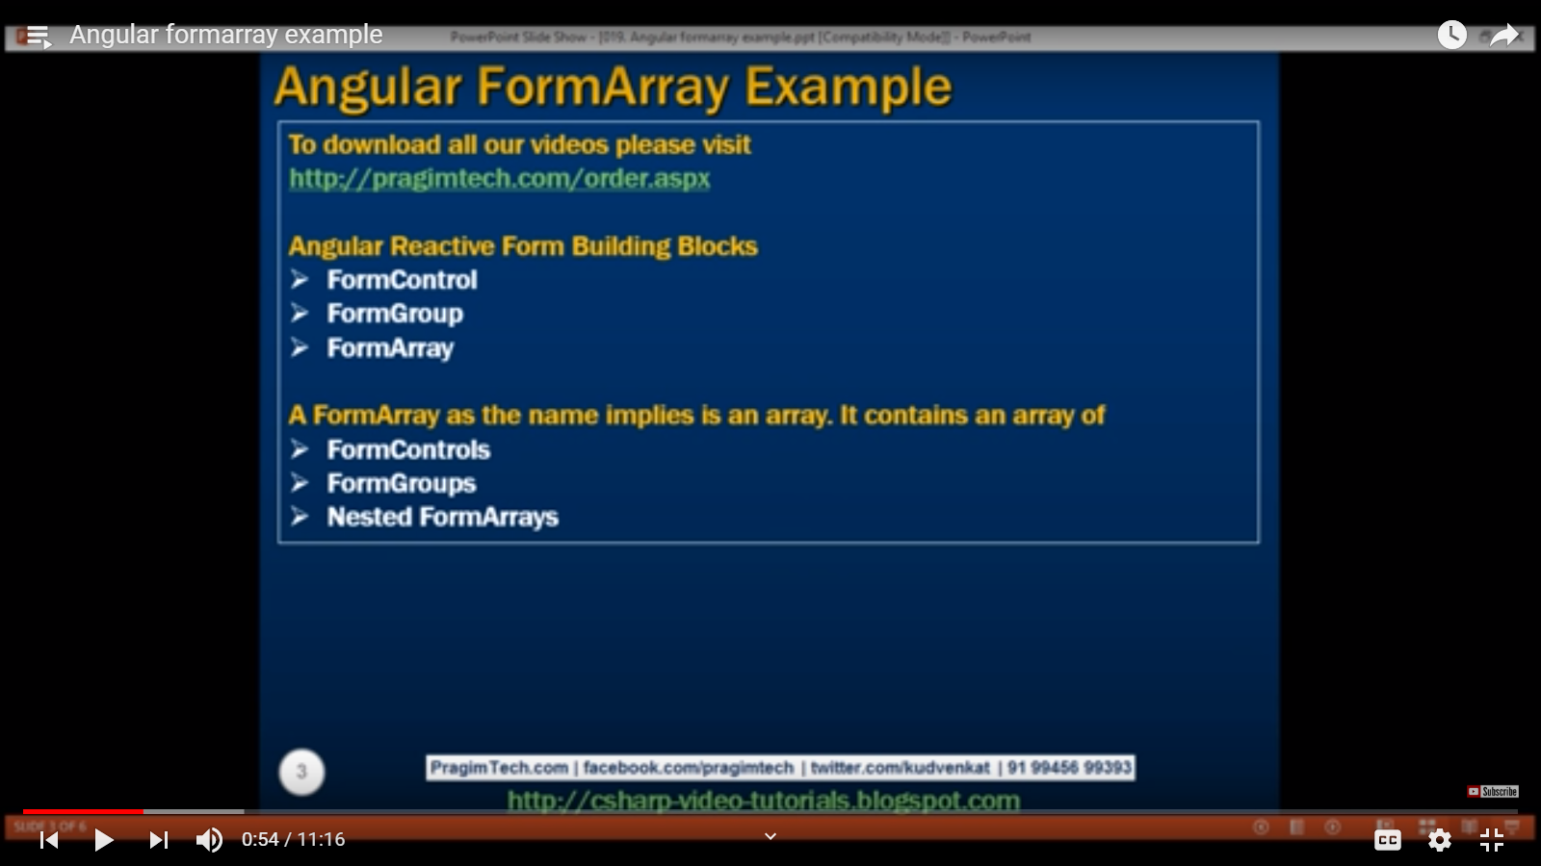

**Part21**

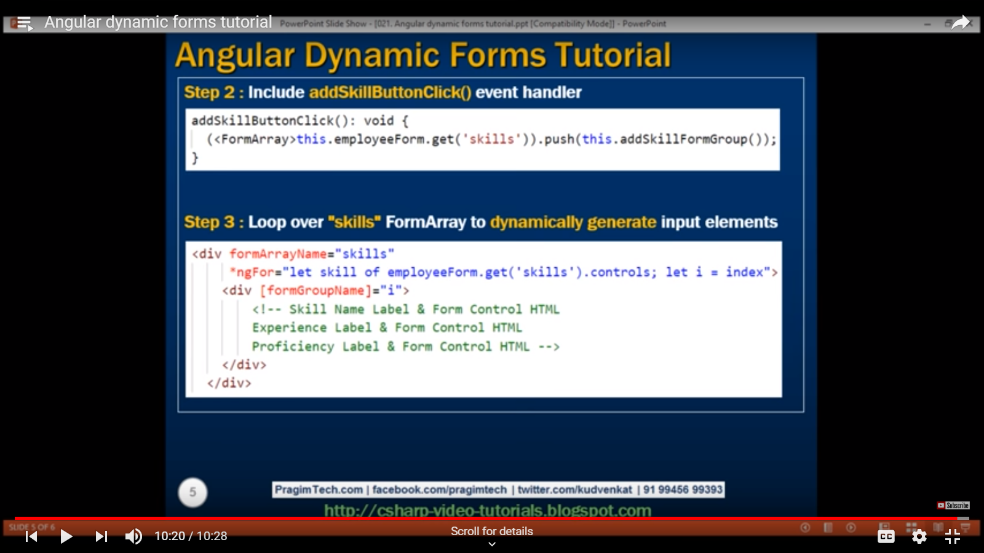

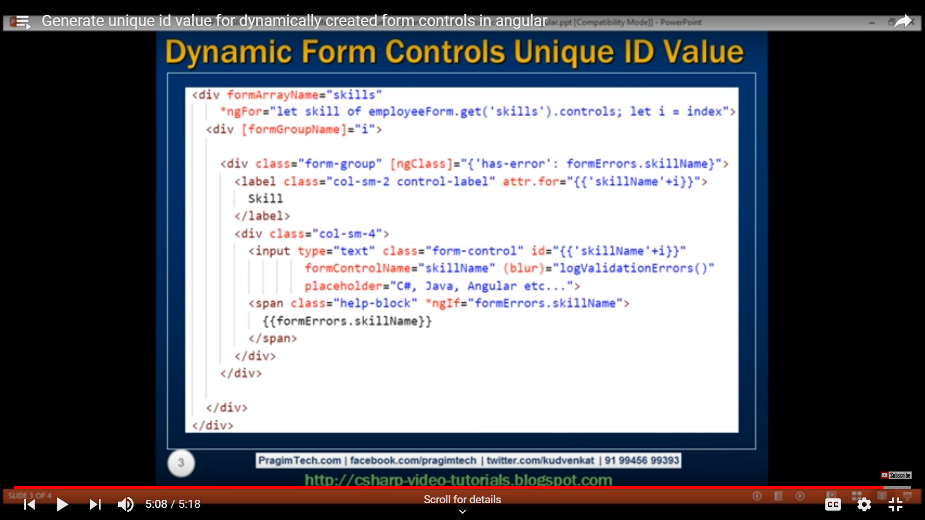

* Part 23 Dynamic form validation
* Part 24
* 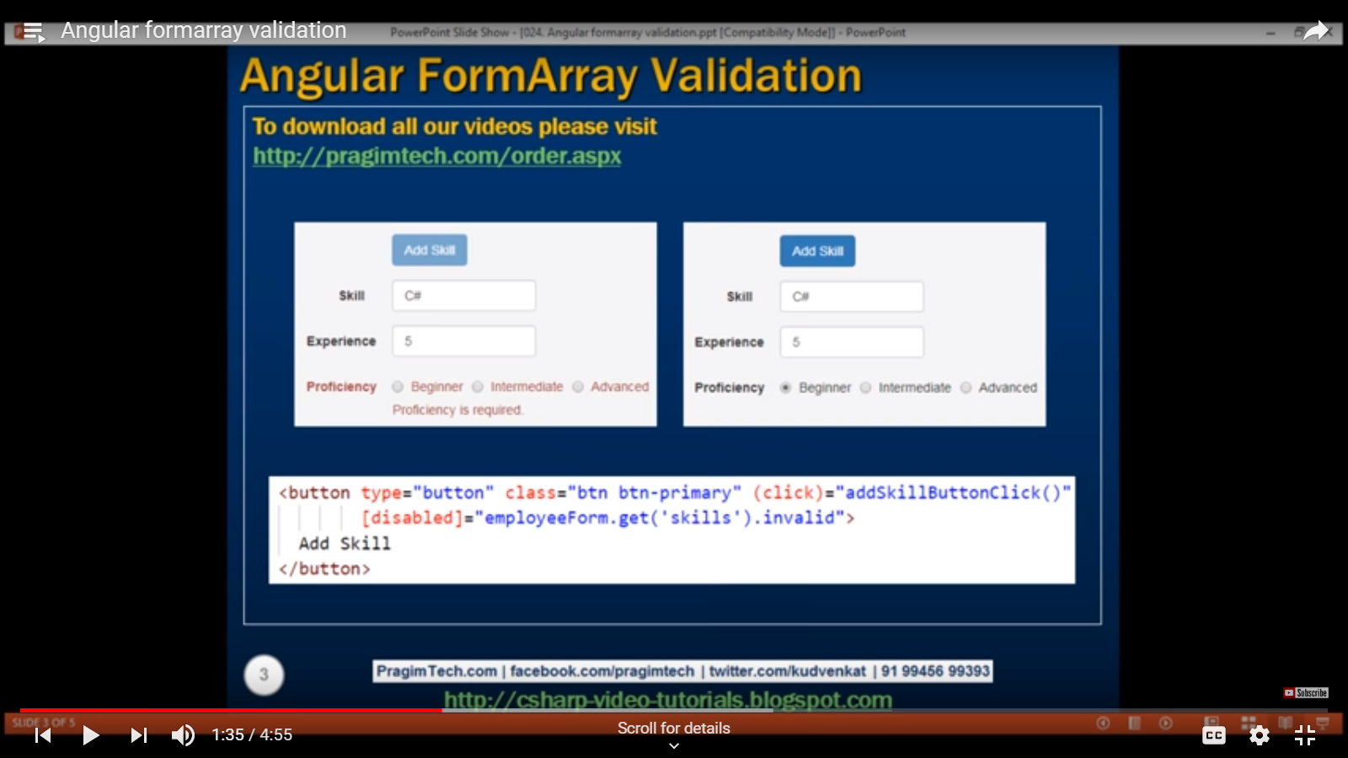

**Part 26 > operators in angular services(By default angular 6 uses rsjx version 6**

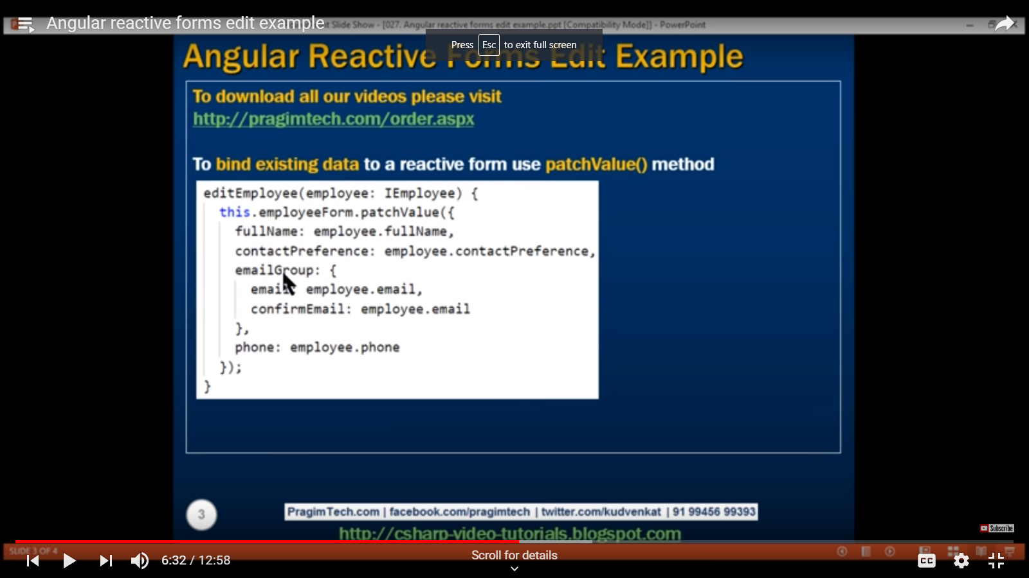

Part: 28> Change JSON

Part 29> Angular Reactive form put examples

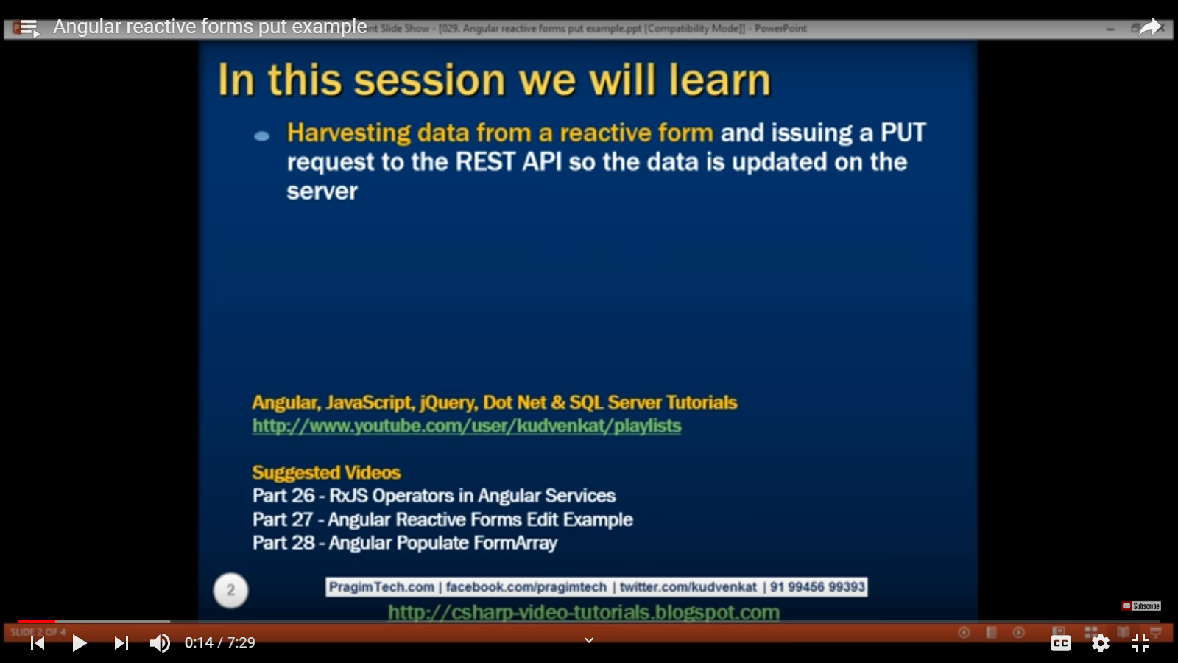

Part 31:Angur Modules Explained

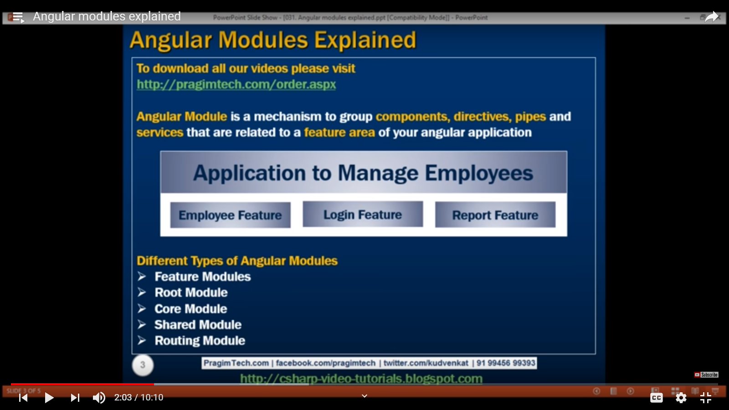

Part 32:> creating separate component for particular module.

Ng g c employee/employee --flat –m app

Part 32> Creating Shared Module

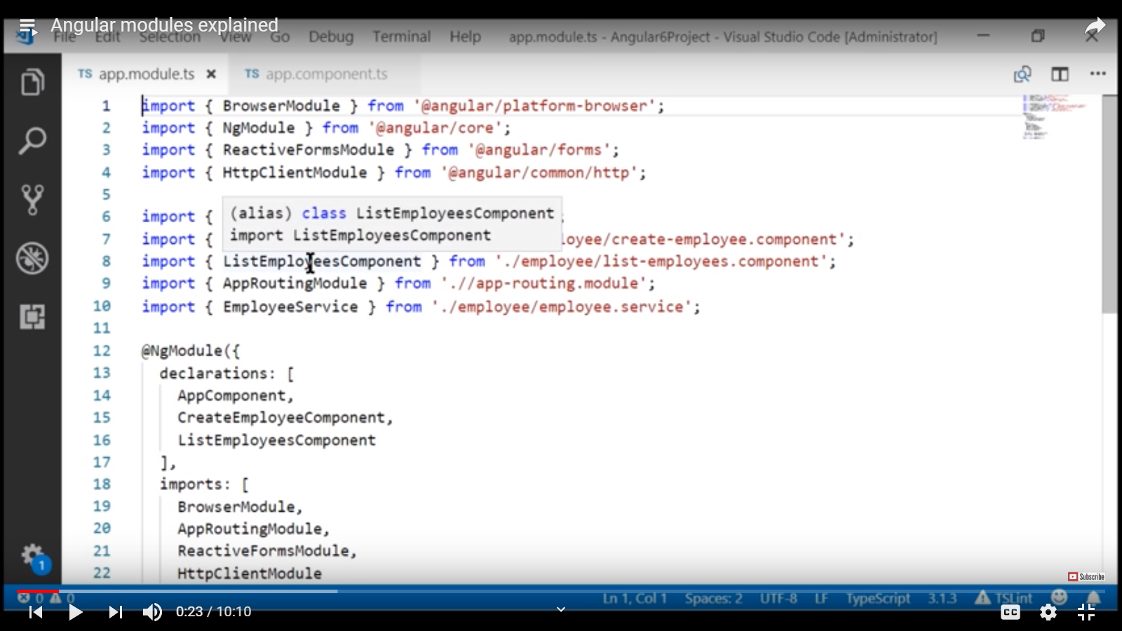

Part:36> 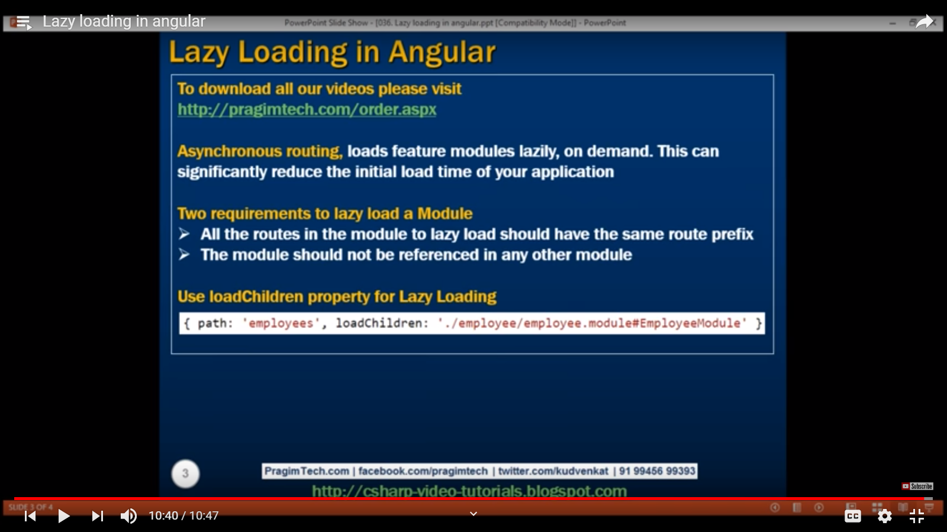

Parr 37:

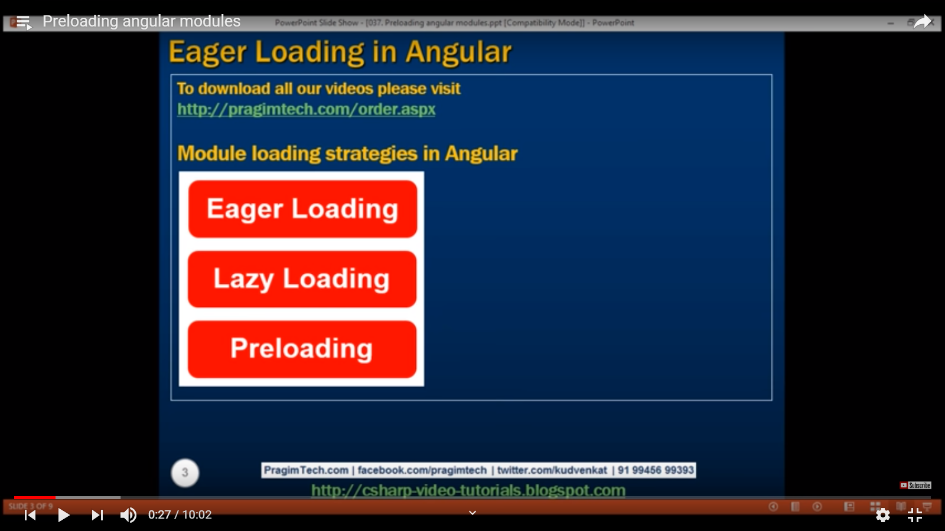

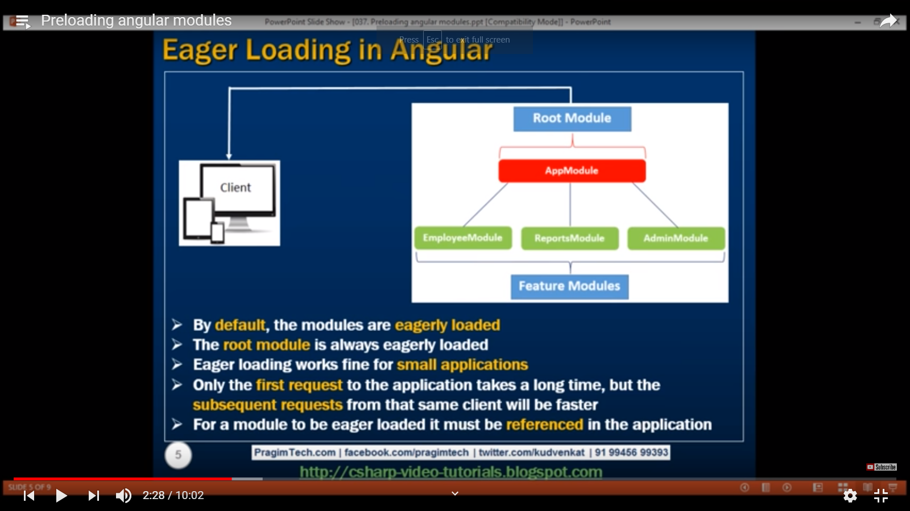

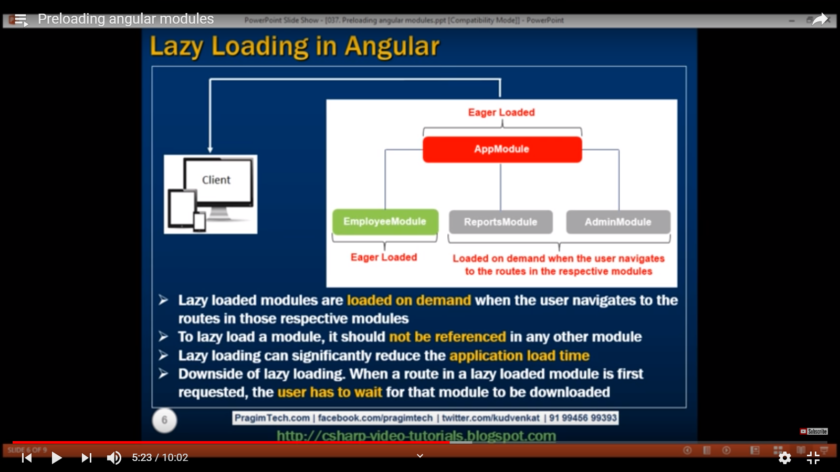

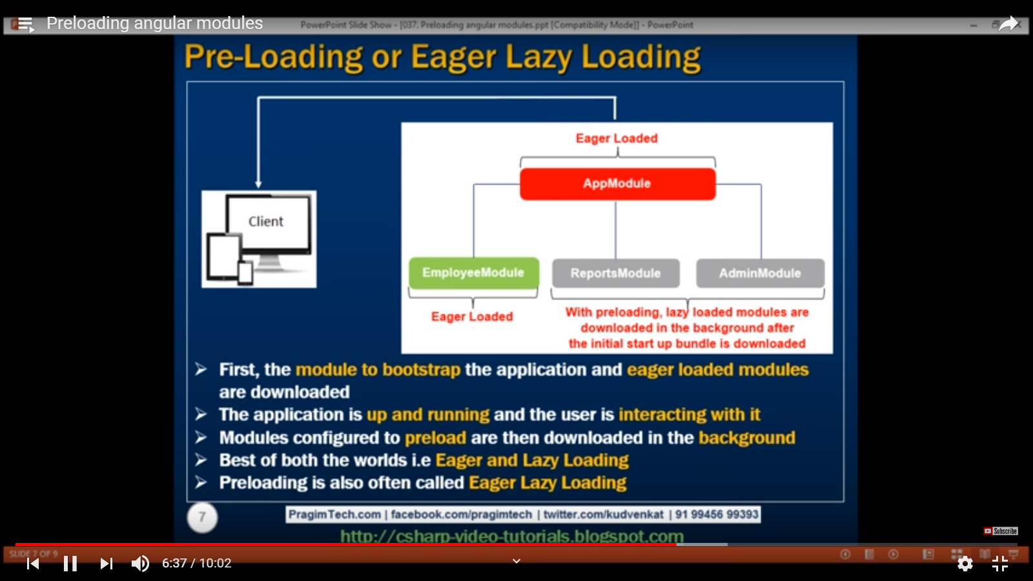

Part 38> Angular custom preloading.

**-------------------------------------------------------------------------------------------------**

**(PWA): Progressive Web Apps**

The feature that comes with the new Angular 6 CLI is `ng add`.

**First, we have to try to convert or turn the regular Angular 6 application to the Progressive Web Apps (PWA):**

ng add @angular/pwa

**We can now update to the required version above simply by using this command.:**  ng update @angular/core

**Back to the PWA, we have to run the Angular 6 PWA application. First, build the Angular 6 PWA by type this command.**

ng buil d --prod

**Next, install `http-server` using NPM command.:**

sudo npm i -g http-server

**Next, go to the built Angular 6 PWA application.**

cd dist/angular6-start/

**Now, we can run the Angular 6 PWA using HTTP-server.**

http-server -p 8000

-----------------------

**Generate Angular 6 Material Components**

Another new feature in Angular 6 is Angular Component that focused material to an existing Angular application. Type this Angular 6 CLI command to add it.

There will be available Angular Starter Material Component. Let's try the starter component for Navigation pane. You may generate the Navigation Component using this command.

ng generate @angular/material:material-nav

========================================================================

**Now AngularCLI configuration -angular.json file**

------------------------------------------

-----------------------------------

-----------------------------------

Note: FormControl and FormGroup are inherit from AbstractControl base class

-------------------------------------

NOdeMailer:

dotenv for hidden password

for install

ionic cordova platform add android

npm i -g cordova-res

ionic cordova resources android --force

**Nodemon:** Nodemon is a utility that will monitor for any changes in your source and automatically restart your server. Perfect for development. Install it using npm.

npm install –g nodemon

nodemon start

**cors:** for cross origin request

npm install –g cors

Note: read configuration parameter from .env file

Var dbCOnn= Process.env.DB_CONN

**OverView Notes**

**Note 1: Jquery , bootstarp & CSS path setup in angular.json file**

**Note 2: Project dependencies can be check in package.json**

**Note 3: Routing module import -> app.module.ts file in**

**export class AppModule{}**

**Note 4: First create Component**